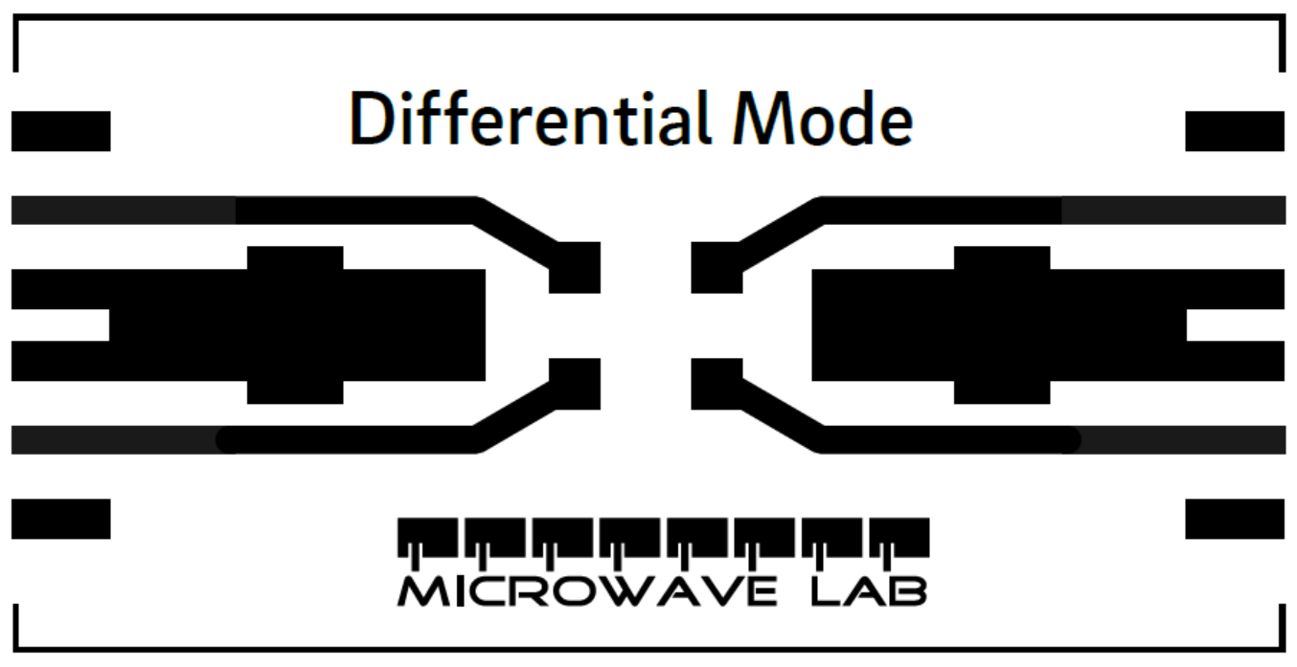

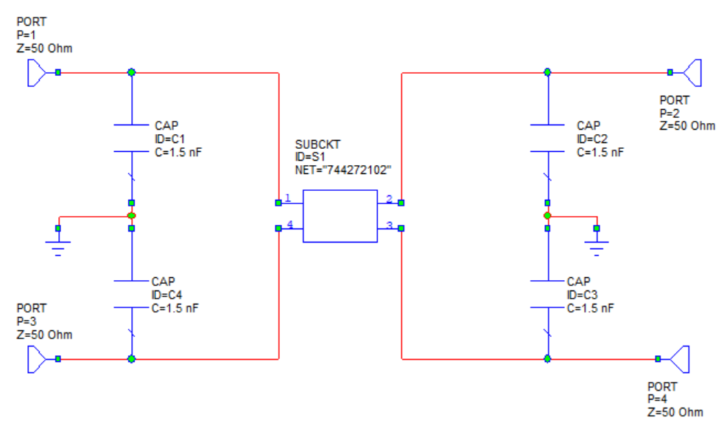

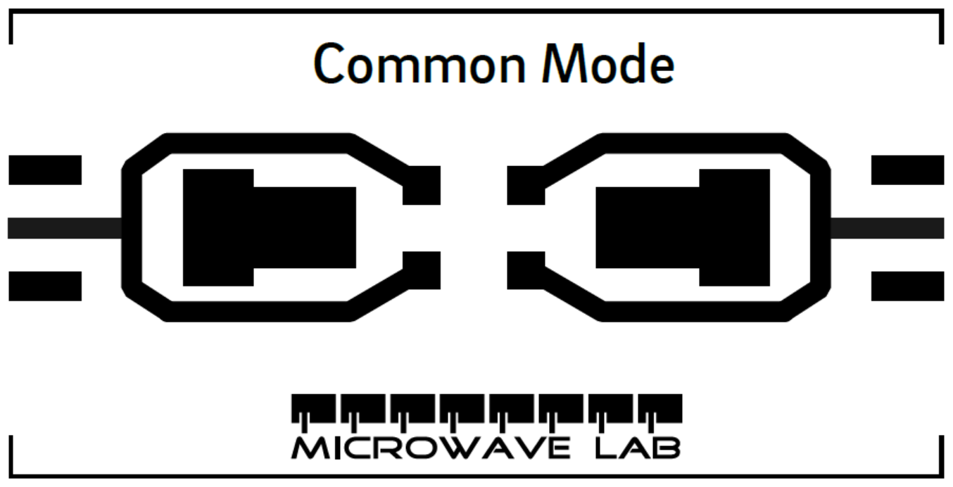

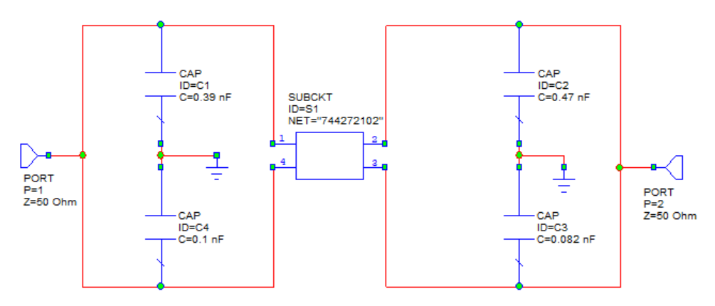

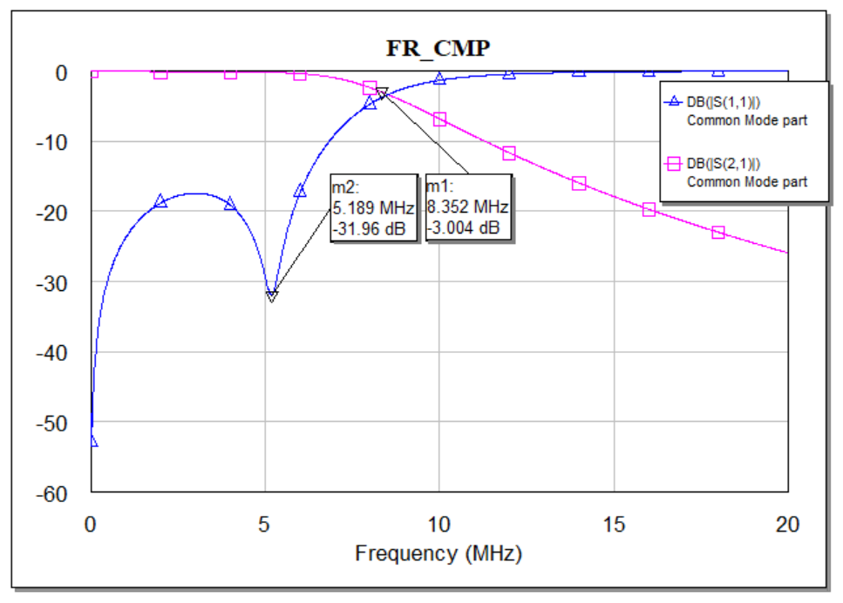

**EMI Filter**

We have designed an Electromagnetic Interference filter

**Passive Components**

1. 744272102 CM choke of 2mH
2. Multilayer ceramic capacitor (100pF, 390pF, 470pF, 82pF)

**Theory**

An EMI filter is placed in between supply (or signal generator) and Load (or LISN). As well as we connect the filter, current will flow through the circuit and induce two different conducted emission. One is called Common mode emission and another is called Differential mode emission. Common mode emissions occur along two lines of a closed-loop simultaneously, and the current flow is in the same direction and in phase. On the other hand differential mode emissions occur along two lines of a closed-loop however, the current flow is in opposite directions and with 180 phase shift. A high frequency noise will also induced. According to the EMI filter purpose this high frequency noise will be regulated by some capacitors. Among these capacitors some will regulate the differential mode noise induced by supply and choke leakage inductance. Some will regulate common mode noise whose high frequency part will be send to ground.

By fixing the values of these capacitors we can determine the actual frequency response both for Ideal and real components and also can compare them.

**Frequency Response**

I have focused on mainly the return loss and the transmission loss while measuring the frequency response. As return loss, I have plotted S11 and as transmission loss, I have plotted S21. In the above structure I have got common mode frequency response where the transmission response showing a nice low pass filter.

For easy simulation purpose I have designed the entire filtering on the basis of mode generated. For the common mode part and differential mode part I have designed and simulated the circuit individually.

For common mode part as the current is passing through from both line and neutral simultaneously and entering to choke and the common mode noise is generating which is being filtered by the common mode choke. Common mode noise is compressed by the capacitors that we have used in the filter schematics C3 and C4. Where these capacitors are connected both with line and ground.

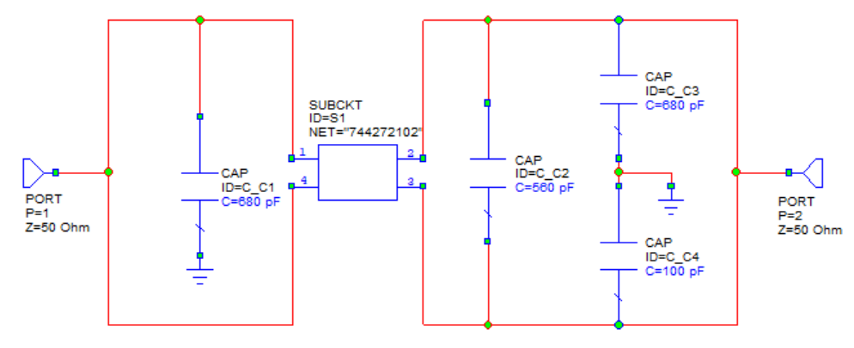

Figure: Common mode current path

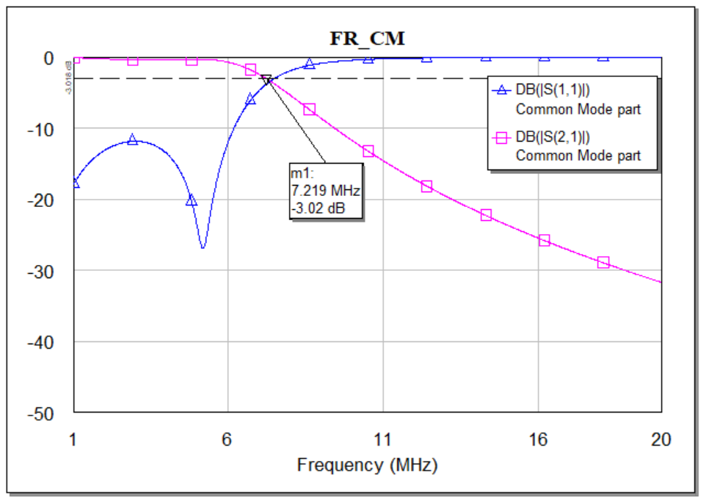

Figure: Frequency response of Common mode part

On the other hand in the Differential mode part the current is flowing through the line and returns through the neutral. The differential mode noise that is creating from the line source is compressed by one capacitor and the leakage inductance which is also a differential mode noise is compressed by another capacitor in the EMI filter.

In the following filter C1 is compressing the source DMN and the capacitor C2 is compressing the leakage inductance noise (by definition).

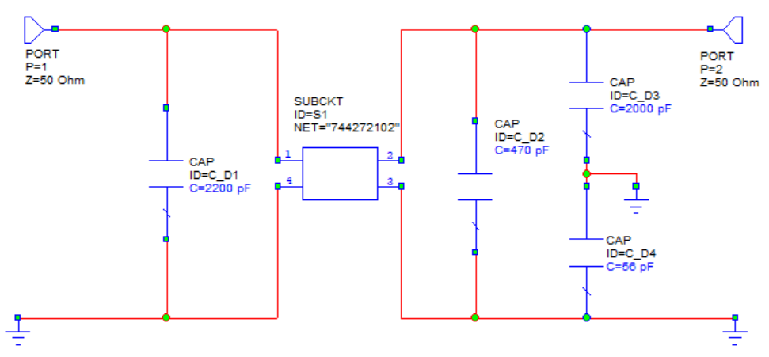

Figure: Differential mode part

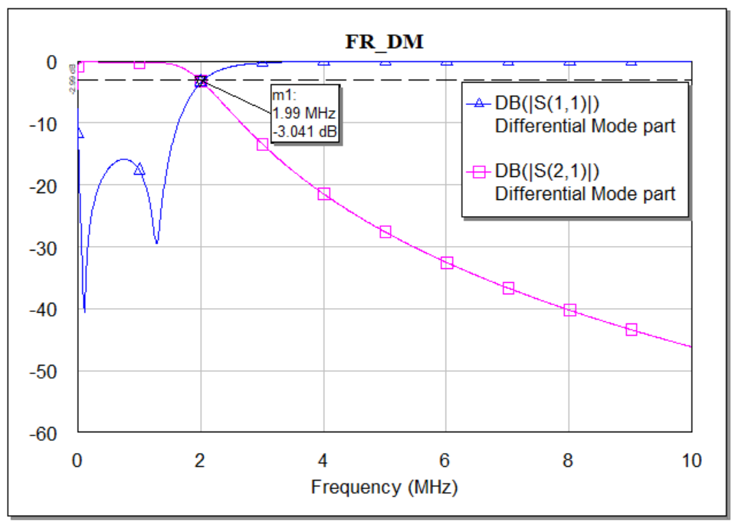

Figure: Frequency response of differential mode part